**Perinatal Mental Health Guidance for Referring to the Leeds Infant Mental Health Service (Pregnancy to Age Two)**

The following guidance focuses on our pregnancy to age two offer of direct work around the caregiver-infant relationship with Leeds Infant Mental Health Service (IMHS). The guidance has been created to support colleagues within the Perinatal Service and acknowledges that both services can often be involved in the care of families, but at times, it can be difficult to ascertain whether a referral to IMHS would be appropriate or not. We have focused on three main areas to optimise the eligibility of referrals into our service and to promote the opportunity to support early relationships. The three areas are:

1. Relationship Need
2. Caregiver Motivation
3. Caregiver Readiness

The guidance offers an understanding around each area and when there is not an indication that a referral to our service is currently appropriate, support to increase levels are considered, how our service might support indirectly, or alternative recommendations offered where appropriate.

Further consideration has been highlighted around:

1. Antenatal Period

This considers when there might be indication that a specialist service around the caregiver-infant relationship is required during pregnancy.

We also consider:

1. What next
2. Other Support Available

**Shaded areas in this document provide an example of eligibility for an IMHS referral. Please note that we would want to see this in all areas (Relationship Need, Caregiver Motivation AND Caregiver Readiness)**

**Overview: Determining Appropriateness of Direct Work with IMHS**

[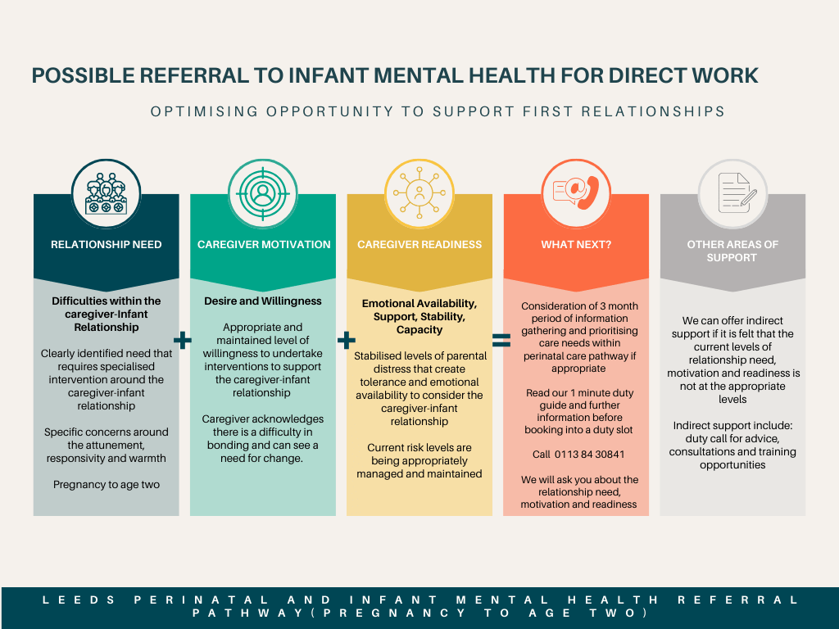](https://gbr01.safelinks.protection.outlook.com/?url=https%3A%2F%2Ftrail.canva.com%2FCL0%2Fhttps%3A%252F%252Fwww.canva.com%252Fdesign%252FDAGLTb_jWIk%252Fshare%253Finvite%3DOgdZRUiv_izH-yFuZS74KA%2526utm_campaign%3Ddesignshare%2526utm_medium%3Demail%2526utm_source%3DshareButton%2F1%2F010001929a181d87-02272171-198d-4b9e-9dd7-e394cb62db77-000000%2FYShJ5cZ2SWaJoD8TVQLqQLOX1gL2qNQ9Mh2feY0Ru8U%3D375&data=05%7C02%7Cgemma.dyble%40nhs.net%7C6f56e6d709874cbf808408dcee994688%7C37c354b285b047f5b22207b48d774ee3%7C0%7C0%7C638647589308120002%7CUnknown%7CTWFpbGZsb3d8eyJWIjoiMC4wLjAwMDAiLCJQIjoiV2luMzIiLCJBTiI6Ik1haWwiLCJXVCI6Mn0%3D%7C0%7C%7C%7C&sdata=fheQM4Y0LLXB0eeFWmJOk%2F7zRkNFTeLIM83PGxoU4AE%3D&reserved=0)

**1. Relationship Need**

There are many reasons why bonding with the baby might be difficult, either in pregnancy or during the first few years of life, such as:

* Difficulties in pregnancy
* A traumatic birth
* Difficult experiences of being parented
* Loss and bereavement
* Difficulties with mental health (such as low mood or anxiety)

Caregivers might share that they haven’t bonded well, it might be stirring up difficult or confusing feelings or there might be worrying or upsetting thoughts about the baby. We support parents and carers in understanding these challenges and developing ways to strengthen the unique relationship. Having a close relationship with baby helps the child to get off to the best possible start in life and grow up feeling safe and secure and able to explore their world as curious and confident children. We help families who are registered with a GP in Leeds and who are struggling with early attachment relationships. We often see families in their own homes.

**Indicators for referral into IMHS**

As a professional, you may have noticed misattunement within the relationship, difficulties reading cues, negative interaction (i.e., language used), a lack of sensitivity. There may be discomfort as you are observing the interactions. You may have noticed a lack of confidence around parenting/becoming a parent. There might be noticed levels of anxiety from the caregiver and/or infant that are not what you would typically expect. Is there disappointment or unrealistic expectations around the relationship. These are examples that indicate further support may be needed around the caregiver-infant relationship.

**Lower Levels of Support Indicated**

There are instances, when there are concerns around the caregiver-infant relationship, but these are minimal or may be appropriate to access via existing support systems.

General concerns around the caregiver-infant relationship but not specific (i.e., not bonding as a general concept and fits typical pattern of general worry) or low-level input required to boost confidence and support better understanding of the infant.

When there are discrepancies between what professionals are observing between the caregiver-infant relationship and what caregiver is reporting (i.e., practitioner is observing good levels of sensitivity, attunement, warmth and responsiveness). Typical levels of ambivalence, anxiety, discomfort, confidence and misattunment experienced from observing the caregiver-infant relationship.

**Supporting the caregiver-infant relationship**

Lower levels of support indicate that internal parent-infant pathways within the perinatal service are currently more suitable. Linking the families with universal services (i.e., Specialist Community Public Health Nurses (SCPHN – ‘Health Visitor’, children’s centres, local baby groups, Understanding Your Baby courses) may be more indicative at this time rather than a specialist IMHS to help the caregiver notice strengths and responsivity in the relationship?

**How can IMHS support you as a professional/service during this period?**

Developing confidence, knowledge and understanding around supporting the caregiver-infant relationship. Access to IMHS training, consultation and advice. Regular interface between the services and opportunity to work together.

**2. Caregiver Motivation**

Motivation is a state of eagerness to change. It is multidimensional, dynamic and fluctuating across situations and over time. It can be influenced by other people. It is important when considering likelihood engagement and completion of interventions around the caregiver-infant relationship and can be a predictor in the level of attainment of Goal Based Outcomes.

**Motivation:** the degree of interest and desire, and willingness to undertake interventions around the caregiver-infant relationship. Seeing the need for and importance of change.

Who is asking for help around the caregiver-infant relationship and seeing the need for change? Is this the family, current professionals involved in the care or both? In the first instance, consideration around informed consent and supporting aligned thinking (whether this is around relationship risk or relationship strengths) may be indicated if the primary ask is from professionals.

Please note that ambivalence and resistance are normal steps and there are likely to be several stages to pass through to achieve the desired changes in the caregiver-infant relationship. It might also be possible to consider other important attachment relationships for the infant and if there is opportunity and a need to work with those relationships.

**Indicators for referral into IMHS**

Suitable levels of motivation are around the caregiver acknowledging there is a difficulty in bonding and can see a need for change. There is a desire or willingness to engage in work to support change in the relationship. There may be obstacles, or the caregiver may feel ‘stuck’ but there is an intention for the relationship to be different or for the caregiver to be different.

**Supporting Motivation**

Motivational Interviewing techniques might be implemented to support this and help an individual become more aware, concerned, hopeful, and confident about change (For example, [How to Assess and Improve Readiness for Change (positivepsychology.com)](https://positivepsychology.com/readiness-for-change/) [Microsoft PowerPoint - MP Motivational Interviewing 2012 (nhsggc.org.uk)](https://www.nhsggc.org.uk/media/231647/1330%20Introducation%20to%20Motivational%20Interviewing%20MP.pdf))

**How can IMHS support you as a professional/service during this period?**

Typically, this is when we might offer a consultation rather than direct work. A consultation is usually offered when a health professional has referred an infant to the IMHS because there are concerns in the professional team about the caregiver-infant relationship or about the infant’s emotional needs not being met. The IMHS clinician will facilitate the virtual consultation which lasts for 90 minutes. A summary of the discussion and any recommendations made will be provided. In the first instance, you will need to contact the IMHS to arrange a duty call with one of our clinicians and complete a referral for a consultation. It will also be helpful to liaise with the allocated health professional (SCPHN or Midwife) to understand how the relationship is currently being supported. For more information around consultations, please see the document below.



**3. Caregiver Readiness**

In this context, we are thinking of emotional readiness which is a state of being prepared and being able to focus and attend, with the ability to regulate emotions and stress, enough to be able to consider the caregiver-infant relationship.

**Readiness:** the degree to which caregivers have the necessary capacity, abilities and resources to engage in the caregiver-infant work (i.e., a level of emotional stability and safety, managed risk-taking behaviours, availability of support system).

The “Window of tolerance” ([How to Help Your Clients Understand Their Window of Tolerance (nicabm.com)](https://www.nicabm.com/trauma-how-to-help-your-clients-understand-their-window-of-tolerance/)) might be a helpful concept to consider and if a caregiver is often outside of this and typically in a state of ‘hyperarousal’ or/and ‘hyperarousal’, this suggests there is a lack of emotional stability, regulation and safety.

Risk taking behaviours (including overactive, aggressive, disruptive or agitated behaviours, non-accidental self-injury, problem-drinking drug-taking. See [calc---honos-additional-guidance-for-perinatal-services-final--11-jan-2022.pdf (rcpsych.ac.uk )](https://www.rcpsych.ac.uk/docs/default-source/improving-care/ccqi/honos/calc---honos-additional-guidance-for-perinatal-services-final--11-jan-2022.pdf?sfvrsn=ff8bf2a7_2) for further examples) that are not being effectively supported are likely to indicate a current lack of readiness.

A support system is a group of people who provide support when most needed and this might be around mental, emotional and or practical. Support might also be internal and around healthy self-care and soothing systems. It is helpful to think about this when considering available resources to support caregiver-infant work.

**Indicators of a referral into IMHS**

Typically, suitable levels of readiness would be reasonable levels of capacity, abilities and resources to engage in the caregiver-infant work. There would be enough emotional stability to be able to consider the infant and the relationship, whilst recognising this may oscillate at times. Current risk levels are being reasonably managed and maintained (for both caregiver and infant) and support systems (whether external or internal) are available and accessed.

**It is important to think about BOTH motivation and readiness and if both are not present, the risk of causing more harm to the caregiver-infant relationship may be present.**

**Supporting Readiness**

It may be necessary to support the emotional regulation and safety, risk-taking behaviours and/or support systems before accessing caregiver-infant intervention. Consideration of what interventions are likely to bring about the necessary changes and what needs to be prioritised?

**How can IMHS support you as a professional/service during this period?**

* Although the caregiver’s readiness is low there is often still a high need in the relationship. IMHS can offer indirect support around the relationship and particularly hold in mind the voice of the infant by supporting existing systems of the caregiver-infant relationship through consultation or accessing Reflective Case Discussions with an IMH practitioner. The system can support fleeting moments of stabilisation where the caregiver-infant relationship can be considered with practitioners already working with the family. Highlighting the risks and concerns specific to the caregiver-infant relationship and for the infant explicitly. A consultation may support the current system to understand better the infant’s voice and their experiences, particularly given that there might be high needs for the caregiver and a risk that the infants voice is overlooked.
* The possibility of offering direct work to other significant caregivers if required and appropriate.

**4. Antenatal Period**

Concerns in the antenatal period often activate a sense of urgency and it is helpful to consider where that urgency is coming from and the right kind of support at the right time. There is a window of opportunity to develop the relationship during utero but also a short period of time which may be a cause for the sense of urgency. It is important to consider when it is helpful to ‘watch and wait’ and to be alongside families with that anxiety and holding the hope, and when it is more appropriate to refer to other services including ourselves. It is usual to have an element of ambivalence about parenthood and there can be additional anxiety around pregnancy when there has been previous loss, fears about the birthing experience or a pattern of typical anxiety that is transferred to the parenthood experience. However, families are usually able to find ways of connecting with the baby before birth and the main fear is around the ***loss*** of the relationship rather than the relationship itself. This suggests that a priority focus would be around supporting caregivers around the identified anxieties and increasing their soothing systems to enable more emotional availability to the developing relationship with the unborn baby, which can be addressed by the professionals currently involved.

**Indicators of referral into IMHS**

An indication of more active work around the caregiver-relationship during pregnancy would be around the level of disconnect from the developing baby. For example, strong negative emotional (i.e., distress, anger, disgust) and/or physical (i.e. recoil, avoidance or harshness of touch) responses to the baby’s presence and/or active avoidance of connecting (i.e. through scans and screening, imagining baby, touching and talking to bump, knowing little about baby’s development). There may be minimal thought and consideration of the developing baby’s needs (i.e. not wanting to implement changes in diet, routine, lifestyle etc that would benefit the baby).

**If a referral to our service is deemed appropriate**

Please refer at the earliest opportunity. It is important to hold in mind that our current waiting times are between 8-12 weeks before we begin working with families. It is helpful to think about what the current system can offer during this time.

**Supporting the antenatal period**

Services already involved might be able to explore why it might be hard to bond with baby and to offer a safe and understanding space around this. Talking and having a practitioner hear these concerns can be a step towards feeling safe and secure with baby. There might also be an opportunity to have space for the concerns alongside the beginnings of conversations around baby’s world and what they need and what can be tolerated. Highlighting and strengthening areas where baby is already being thought about and considered. The following resources might be helpful:

* Bonding with your baby: [Building a close relationship with your baby - Start for Life - NHS (www.nhs.uk)](https://www.nhs.uk/start-for-life/baby/baby-basics/bonding-with-your-baby/building-a-close-relationship-with-your-baby/#during-pregnancy)
* Watch a series of films about baby bonding, and mental health during the perinatal period; www.bestbeginnings.org.uk
* Pregnancy, parenthood and Mental Health. Information for Patients: [5617-pregnancy-and-mental-health-leaflet-final.pdf (penninecare.nhs.uk)](https://www.penninecare.nhs.uk/application/files/4915/6146/8817/5617-pregnancy-and-mental-health-leaflet-final.pdf)
* Attachment and Bonding During Pregnancy: [Attachment and bonding during pregnancy | Ready Steady Baby! (nhsinform.scot)](https://www.nhsinform.scot/ready-steady-baby/pregnancy/relationships-and-wellbeing-in-pregnancy/attachment-and-bonding-during-pregnancy/)

**5. What Next?**

As a service, you may want to consider a 3-month period of information gathering and prioritising needs within your perintatal care pathway if this is deemed appropriate and “watchful waiting” for those families where there are low or moderate relational need. However, if this period of wait is likely to cause further harm to the relationship and there are appropriate levels of motivation and readiness, direct work could be indicated.

Please see below for futher information around our duty calls and the proforma for what we will discuss. Essentially, during the 30 minute telephone conversation, we will explore concerns and strengths around the caregiver-infant relationship, what the infant might be telling us, the emotional availability and readiness to consider the relationship and contextual and key historic information as well as current support systems. We will also complete the ‘Parent-Infant Relationship Risk Factors’ screening. At the end of the call, the IMH practitioner will give an indication as to whether this is an eligible referral for the service (this can include direct and consultation).

A completed referral can then be sent to [leedsimh@nhs.net](mailto:leedsimh@nhs.net). All referrals are discussed at a weekly ‘Referral Management Group’ and an outcome or further information required will be communicated to all referrers in a timely manner. Any accepted referrals for direct work are currently waiting approximately 8-12 weeks before being allocated a clinican. It would be helpful, in addition to the referral form, to provide information around the care-coordinator and key perinatal staff (and any internal pathways being accessed i.e., psychological therapies, parent-infant relationships). It would be helpful to include updated risk assessments and Care Plans.

  

**6. Other Areas of Support**

Throughout the document, we have highlighted if non-direct work is not indicated currently, what we can offer indirectly in relation to supporting the voice of the infant. This can be accessed through our professional consultations, duty calls and advice, and possibly the implementation of Reflective Case Discussions (RCD’s) if this is deemed possible and helpful. There are also training opportunities around the caregiver-infant relationship. Lower levels of suupport indicated may suggest accessing the internal parent-infant pathways within the perinatal service. Linking the families with universal services (i.e., Specialist Community Public Health Nurses (SCPHN – ‘Health Visitor’, children’s centres, local baby groups, Understanding Your Baby courses) may be more indicative at this time rather than a specialist IMHS.

**Additional Resources**

* Leeds Infant Mental Health Video: [Leeds Infant Mental Health Service (youtube.com)](https://www.youtube.com/watch?v=is8VuXrhLZ0&t=2s)
* [Reflecting on parent-infant relationships: a practitioner’s guide to starting conversations - GOV.UK (www.gov.uk)](https://www.gov.uk/government/publications/parent-infant-relationships-starting-conversations-practitioner-guide/reflecting-on-parent-infant-relationships-a-practitioners-guide-to-starting-conversations)
* Understanding Your Baby Leaflet: Understanding your baby_Sept'23.pdf
* Understanding Your Baby Videos: [An introduction to 'Understanding Your Baby' (youtube.com)](https://www.youtube.com/watch?v=CrDmjdSxG5g)
* Understanding Your Baby Additional: [Understanding your baby - Start for Life - NHS (www.nhs.uk)](https://www.nhs.uk/start-for-life/baby/baby-basics/bonding-with-your-baby/understanding-your-baby/)
* [About Watch Me Play! - Watch Me Play](https://watchmeplay.info/)