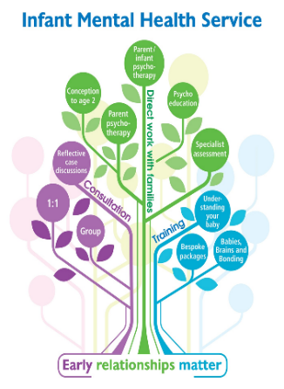

**One Minute Guide to a Duty telephone call with the Infant Mental Health Service**

We continue with our two-step process of a **duty call first and a following Referral Form** as this process is necessary as a specialist service to help clarify the infant’s experience and focus on the relationship. It is important from a safeguarding perspective that we then receive a formal referral in writing that captures referrer’s concerns in their words.

What to expect from a duty call with an IMH practitioner:

* 45 minutes will be allocated to discuss the infant/family. This should allow time for discussion and for completion of the referral form if appropriate. Please note that the call can also be used for advice only. Prior to the call, it is helpful to have the infant’s record open and be in a quiet space to enable you to join the call.
* A summary of the telephone call will be recorded by the IMH practitioner on the infant’s record on SystmOne (or Mother’s record if an antenatal referral).

The key points to consider in duty calls are:

* What are the concerns about *the relationship* (i.e. details of any misattunement, disconnection, distance, anxiety etc. that impacts upon the infant’s world/experience of caregiving)
* What *the infant* is telling us (ideally by the 6-8 week Early Attachment Observation or observing the infant or referrer liaising with 0-19 Service)
* If there is a level of *emotional availability* or readiness from the parent/caregiver to think about their relationship with their infant
* *Contextual/ historic* information of relevance
* What *involvement* other services are having e.g. ongoing plans to manage maternal mental health and any identified risks – for example, Perinatal Mental Health Support in addressing for example trauma or emotional instability often helps us to create the space to safely hold the infant’s experience in mind
* Whether any universal services are involved/can help first/what’s been done already

The IMH clinician will support professionals in thinking about what is best for the infant’s emotional needs.

We will then complete a brief risk screening form to get a fuller understanding of the infant’s experience.

At the end of the call, the IMH practitioner will give an indication as to whether or not this is an eligible referral for the service.