**Physical Activity Resource Sheet**

Here are some useful links of practical ways to get you started with increasing your activity levels.

|  |  |
| --- | --- |
| **Ted talks**  **Elongated speech bubble**   * How To Enjoy Exercise And Train Happy: Tally Rye.[**https://www.youtube.com/watch?v=oBtlNKKFuyw&t=539s**](https://www.youtube.com/watch?v=oBtlNKKFuyw&t=539s) * Forget big change, start with a tiny habit: by BJ Fogg. <https://www.youtube.com/watch?v=AdKUJxjn-R8> | **Exercise snacking**   * Random exercise generator: [https://www.overstellar.se/random-exercise/#](https://www.overstellar.se/random-exercise/) * Podcast with Michael Mosley: <https://www.bbc.co.uk/programmes/m000zljp> * A cookie with sprinkles and bite marksHere’s a tiny habits recipe maker: <https://recipemaker.tinyhabits.com/tiny-habits> |
| **Suburban scene with solid fillGetting started with home workouts**   * If you’re struggling for time, here is a 5-minute kitchen workout with Dr Chatterjee! <https://drchatterjee.com/5min-kitchen-workout> * Chair based exercises- <https://www.bhf.org.uk/informationsupport/heart-matters-magazine/activity/chair-based-exercises/5-more-chair-based-exercises> * Get fit with Rick - <https://www.youtube.com/watch?v=TCbv2PrIwOQ> * 5 minutes dance workout- <https://www.youtube.com/watch?v=gqu-_DMnwfk> | **An introduction into strength training**   * Useful information: <https://www.thebodycoach.com/blog/a-beginners-guide-to-strength-training/> * **Body weight –** [**https://darebee.com/muscle-map.html**](https://darebee.com/muscle-map.html) * Resistance bands-[**https://darebee.com/workouts/bandit-workout.html?epik=08KoREvIWX_R_**](https://darebee.com/workouts/bandit-workout.html?epik=08KoREvIWX_R_) * Spiral open diary laid on blue wooden floorDumbbell-[**https://darebee.com/workouts/forever-young-workout.html**](https://darebee.com/workouts/forever-young-workout.html)   **Exercise Diary**   * Plan for the week ahead, schedule active days. Tick off each day achieved. * Note how much completed and how you felt during/afterwards. * Use this to look back on your progress. * Free printable exercise diary available here: <https://livefit.com/blogs/livefit/fitness-journal> |
| **Tips for motivation**  Aspiration with solid fill   * Find activities that you enjoy * Set goals * Be active with others * Combine with your favourite music playlist / podcast * Have a back up plan, remember some is better than none! | **Apps**  **Mobile phone and text message bubbles**   * NHS Active 10 walking tracker- measures brisk walking pace. * pedometer++- step counter. * Strava- measures distance walked. * Couch to 5k |

**Physical Activity support in the community**

**Active Leeds - Health Referral Programme**

* Available for targeted areas only- some of LS7/8, all of LS9, LS10, LS12, LS13, LS28.
* You will be allocated a Health & Wellbeing Coach who will support you to increase your physical activity levels with a bespoke personalised plan and regular check ins.
* Discounted membership of £5 a month if in targeted postcode, otherwise 7 day free pass.
* You can self refer here - <https://secure.refer-all.net/referrals/Leeds/ReferLeeds?id=5562&name=Leeds%20Encouraging%20Activity%20in%20People>
* For more information see: <https://active.leeds.gov.uk/active-leeds-for-health>
* Note the most accessible swimming pools in Leeds are: Morley, Rothwell, Holt Park and Armley.

**Nuffield Health Joint Pain Program**

* Support to exercise specifically for those with joint pain
* This involves a free12-weeks course of 2 sessions a week in any Nuffield Health Centre.
* It also includes free access to gym/swim/classes with personal trainer support.
* You can self refer here - <https://www.nuffieldhealth.com/about-us/our-impact/healthy-life/joint-pain-programme>

**Leeds United Football Club Positive Goals**

* Positive Goals is a 12-week health and wellbeing weight management programme which aims to work towards improving overall lifestyle choices. Note this programme costs £60 for 12 weeks or £5 per session. Each 2-hour weekly session consists of 1 hour of classroom-based activities and 1 hour of physical activity.
* Website: <https://www.leedsunited.com/foundation/health-wellbeing/positive-goals>
* Tel: 0113 367 6598
* Email: [fitleeds@leedsunited.com](mailto:fitleeds@leedsunited.com)

#### A directory of free groups from Being You Leeds, running 7 days a week, including on evenings and weekends in local venues across Leeds.

<https://www.mindwell-leeds.org.uk/being-you-leeds/groups-and-activities/>

**A Directory of exercise classes, run by Leeds City Council**

<https://active.leeds.gov.uk/classesandactivities/fitnessclasses?Category=Fitness+Class>

**A Directory of support groups and exercise facilities available across Leeds.**

[www.Leedsdirectory.org](http://www.Leedsdirectory.org) - see section on ‘Keeping Active and well’

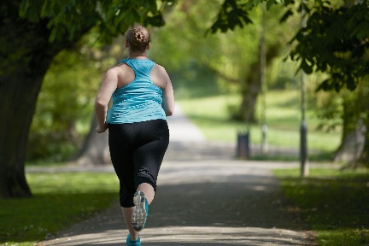 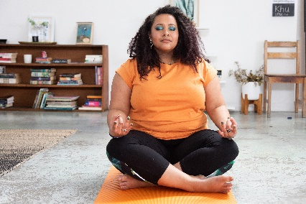 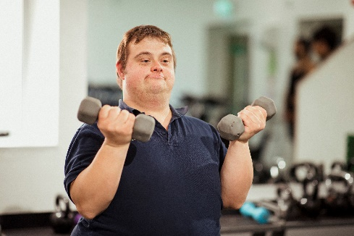

**Accessible Swimming facilities**

Aireborough, Armley, Holt Park, Morley and Pudsey have graded steps for easier entry into the pool.

Fearnville and Scott Hall have mobile graded steps that can be put in place for easier access- these must be prebooked via reception.

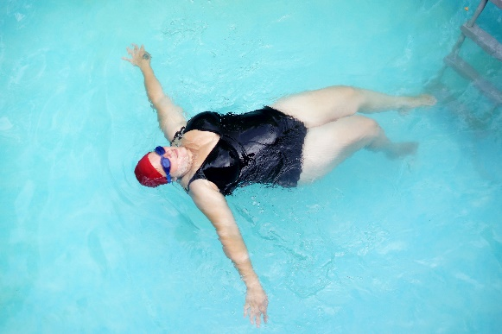 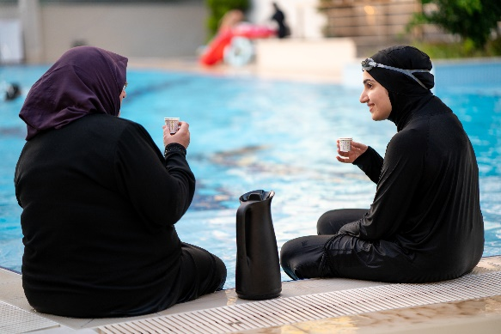

**Hydrotherapy- at Holt Park**

A screening form needs to be filled in prior to use. Any carers will also need to fill in part of the form too.

Price: £11.50 per session

How to book: Telephone (0113) 3760398 or or drop into site.

Accessibility: The hydro pool is accessible via lift downstairs. It has a hoist and the limit is 140kg. We do not have slings so would need to provide your own. There are also graded steps for easier access, not ladder stairs.

**Session times:**

Monday 10:30 – 11:00, 12:00 – 12:30, 18:15 – 18:45

Tuesday 10:30 – 11:00, 12:00 – 12:30, 13:30 – 14:00, 18:15 – 18:45

Wednesday 12.00-12.30

Thursday 10:30 – 11:00, 12:00 – 12:30,13:30 – 14:00

Friday 10:30 – 11:00, 12:00 – 12:30

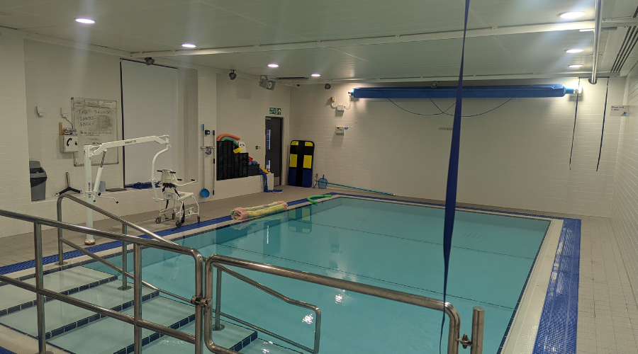

**Hydrotherapy- at Armley**

A screening form needs to be filled in prior to use. Any carers will also need to fill in part of the form too.

How to book: Telephone (0113) 3760398 Armley or drop into site.

**Session times:**

Tuesday 12.15 – 13.00

Tuesday 18.30 – 19.15

Wednesday 12.15 - 13.00

Wednesday 18.30 – 19.15

Thursday 12.15 – 13.00

Sunday 12.00 – 12.45

Accessibility: The weight limit for the hoist is 272kg. We do not have slings so would need to provide your own. There are also graded steps for easier access, not ladder stairs.

