# Joining a Preparation for Birth and

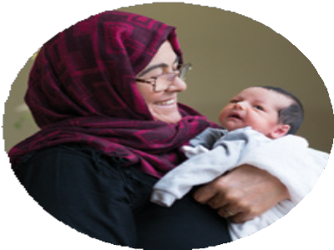

**Beyond course**

You need to be around 24 weeks pregnant at the time of booking on to a course and pay your community charge to Leeds City Council. You can find out more information regarding dates, times, venues and booking on to a course by scanning the QR code or you can book on **Eventbrite** by searching for **Leeds Community**

**Healthcare 0-19 PHINS**. If you are unable to access Eventbrite or need help to book a place, please contact us on **0113 843 5683**.

For more information about the 0-19 Public Health Integrated Nursing Service please visit: [**www.leedscommunityhealthcare.nhs.uk**](http://www.leedscommunityhealthcare.nhs.uk/)

You can also find us on Facebook:



## 0-19 Public Health Integrated Nursing Service

and Instagram:

[**https://www.instagram.com/019phinsleeds/**](http://www.instagram.com/019phinsleeds/)

# Help us get it right

If you have a complaint, concern, comment or compliment please let us know by speaking to a member of our staff. We learn from your

feedback and use the information to improve and develop our services.

If you would like to talk to someone outside the service contact the **Patient Experience Team** on **0113 220 8585**, Monday to Friday 9.30am to 4.30pm or email [**lch.pet@nhs.net**](mailto:lch.pet@nhs.net)

**We can make this information available in Braille, large print, audio or other languages on request.**

© Leeds Community Healthcare NHS Trust, March 2024 ref: 2272 v4



Preparation for

Birth and Beyond

**Public Health Integrated Nursing Service**

**0**-**19**

**Preparation for**

**Birth and Beyond course**

As a first time parent we would like to invite you to attend the Preparation for Birth and Beyond antenatal course. The course is delivered in a group setting either virtually or face to face. Face to face courses are delivered at a Children’s Centre. The course consists of four antenatal sessions and one post-natal session and aims to prepare you for the many changes having a new baby will bring. The course is unique in that it focuses on the experience of the baby and supports parents and carers to get to know and respond to their baby’s needs.

The course sessions are delivered by members of the Early Start team, which includes

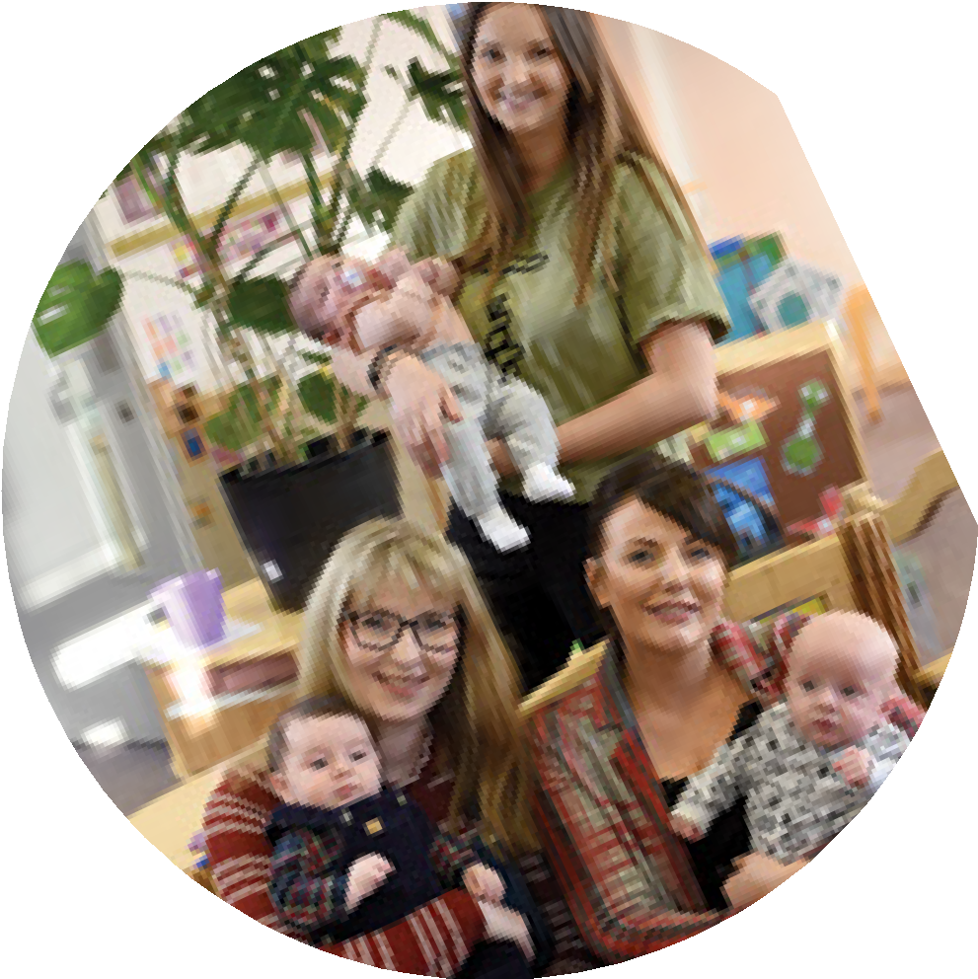

**Course outline**

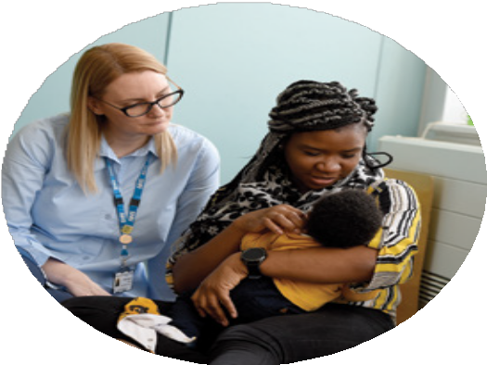

**Sessions 1-4 are usually delivered**

There’s all the information on the

a 0-19 Specialist Public Health Nurse (Health Visitor), Family Outreach Worker and Community Midwife.

At the end of the course you may wish to keep in contact with new parents

you have met on this course or meet other parents in your area.

We enjoyed the

interactive activities and discussions and learned that I’m not the only one who is nervous.

**over four consecutive weeks, and are approximately two hours duration.**

**How to support your**

**1**

**baby’s physical and emotional development.**

internet, but it’s the fact that you get to ask

questions - get our specific concerns out there and get answers to

them.

The Early Start team will be able to give you information on how

to access groups and support across Leeds.

We’ve enjoyed having focussed time to think about our baby and have learnt lots.

**How to recognise what your baby is telling you.**

**Responsive feeding.**

**2**

**Support available in your area.**

**3**

**How to keep your baby safe.**

**The importance of looking after yourself. How to manage changes in relationships.**

**4**

**Labour, birth, the role of the birth partner and the benefits of skin-to-skin.**

**5**

**Post-birth reunion.**