
Lifestyle Diary

NAME: ………………………………………….

DATE OF BIRTH: ………………………………………….

DATE RECORD STARTED: ………………………………………….

Keeping a diary of what you eat and drink for a few days can help you to find out what you actually do day by day.

We can be affected by how we feel and any symptoms we may have, so recording these can also help plan changes or see if changes are having the effect wanted.

Doing a diary is the first important step.
Once completed it can be used to work out where you can start to make the changes you want to make.

The diary should be filled in for seven continuous days.
- Please record everything that you eat and drink over the seven days even if it is during the night.
- Please record your feelings and symptoms even if it is during the night.

Handy hints
- Write everything down that you eat or drink
- Do it as you go along
- If you use any manufactured foods, write down the make
- Try to give an idea of the amounts e.g. number of tablespoons etc
- Fill in the sections on where you are, how you feel and what you were doing at the time. This may highlight times and places which you find difficult.
- Hunger scale to help – see overleaf

Please look at your diary and complete the summary section to help plan areas to change with your GP or Dietitian

Provided by

Nutrition & Dietetic Department

Parkside Community Health Centre
311 Dewsbury Road
Leeds
LS11 5LQ

Hunger Scale

1 | Starving
2 | Hungry
3 | Peckish
4 | Comfortable
5 | Full
6 | Overfull and feeling sick

Mood Scale

1 | Happy
2 | Content
3 | Relaxed
4 | Tired
5 | Some anxiety
6 | Very anxious/stressed

Bowel Symptom Scale please record as many as apply

1 | Abdominal Pain
2 | Abdominal discomfort
3 | Abdominal bloating with or without passing wind
4 | Bowels Type 3 or 4 or 5
5 | Constipation Type 1 or 2
6 | Diarrhoea Type 6 or 7
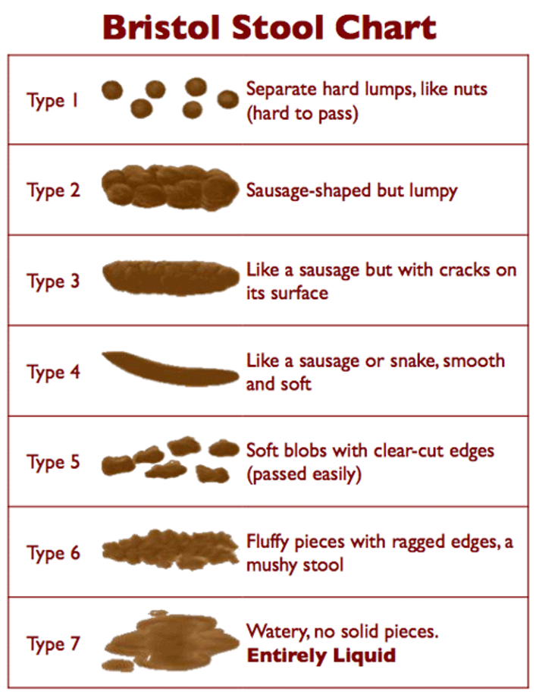

Patient Name………………………………………….. Date……………. Day of week………………….

Time  Eg | How much  eaten or drunk | What-  Please describe | Physical Activity  Write in any activity  the time and duration | Hunger scale | Mood Scale  and  comments | Bowel Symptoms Scale and comments
6.00am

9.00am

12 noon

3.00pm

6.00pm

9.00pm

Midnight

During
the night

Patient Name………………………………………….. Date……………. Day of week………………….

Time  Eg | How much  eaten or drunk | What-  Please describe | Physical Activity  Write in any activity  the time and duration | Hunger scale | Mood Scale  and  comments | Bowel Symptoms Scale and comments
6.00am

9.00am

12 noon

3.00pm

6.00pm

9.00pm

Midnight

During
the night

Patient Name………………………………………….. Date……………. Day of week………………….

Time  Eg | How much  eaten or drunk | What-  Please describe | Physical Activity  Write in any activity  the time and duration | Hunger scale | Mood Scale  and  comments | Bowel Symptoms Scale and comments
6.00am

9.00am

12 noon

3.00pm

6.00pm

9.00pm

Midnight

During
the night

Patient Name………………………………………….. Date……………. Day of week………………….

Time  Eg | How much  eaten or drunk | What-  Please describe | Physical Activity  Write in any activity  the time and duration | Hunger scale | Mood Scale  and  comments | Bowel Symptoms Scale and comments
6.00am

9.00am

12 noon

3.00pm

6.00pm

9.00pm

Midnight

During
the night

Patient Name………………………………………….. Date……………. Day of week………………….

Time  Eg | How much  eaten or drunk | What-  Please describe | Physical Activity  Write in any activity  the time and duration | Hunger scale | Mood Scale  and  comments | Bowel Symptoms Scale and comments
6.00am

9.00am

12 noon

3.00pm

6.00pm

9.00pm

Midnight

During
the night

Patient Name………………………………………….. Date……………. Day of week………………….

Time  Eg | How much  eaten or drunk | What-  Please describe | Physical Activity  Write in any activity  the time and duration | Hunger scale | Mood Scale  and  comments | Bowel Symptoms Scale and comments
6.00am

9.00am

12 noon

3.00pm

6.00pm

9.00pm

Midnight

During
the night

Patient Name………………………………………….. Date……………. Day of week………………….

Time  Eg | How much  eaten or drunk | What-  Please describe | Physical Activity  Write in any activity  the time and duration | Hunger scale | Mood Scale  and  comments | Bowel Symptoms Scale and comments
6.00am

9.00am

12 noon

3.00pm

6.00pm

9.00pm

Midnight

During
the night

