Bariatric surgery information
Please note throughout this document, the different tier services will be referred to:
The tier 3 service is the weight management service you are currently a part of.
The tier 4 service is the bariatric surgery service.
This leaflet is intended for guidance only. Please discuss bariatric surgery further with appropriate healthcare professionals.
What is bariatric surgery?
Bariatric surgery is a surgery that reduces the size of your stomach and can stop you absorbing some nutrients. This can support weight loss and help improve several obesity-related conditions, such as type 2 diabetes or high blood pressure. The surgery is intended as a tool, rather than a complete solution as long-term lifestyle changes need to be made for it to be effective.
How can I have bariatric surgery?
Bariatric surgery is available through the NHS, however certain criteria need to be met.
The current UK National Institute for Health and Care Excellence (NICE) CG189 guidelines advise that bariatric surgery is a treatment option for people living with obesity if the following criteria are fulfilled:
• They have a Body Mass Index (BMI) of 40 kg/m2 or more, or between 35 kg/m2 and 39.9 kg/m2 with a significant health condition that could be improved if they lost weight (for example, cardiovascular disease, hypertension, idiopathic intracranial hypertension, non-alcohol fatty liver disease, obstructive sleep apnoea, type 2 diabetes) and
• Agree to the necessary long-term follow up after surgery (e.g. lifelong annual reviews).

If you are unsure of your current BMI please search NHS BMI calculator - this will send you to a webpage to calculate this.
Leeds Community Healthcare Criteria (tier 3 service):
• Attendance to appointments. If there have been three non-attendances, this will likely result in discharge back to the GP.
• There has been some weight loss or at least no weight gain during the time under the tier 3 service as evidence to the surgeons that changes have been made for surgery. Initial and final weights will be taken at our in person metric clinics.
• Engagement with all clinicians at appointments and willingness to make changes. Medical, dietetics and, if appropriate, psychology/CBT will all need to give the go ahead for referral to surgery and further discussion may be required if there are any concerns. Please note referral on for a sleep study may also be required prior to tier 4 referral if there are any concerns sleep apnoea is present (CPAP support may be required prior to surgery).
• At least two Sunday online (via Zoom) bariatric support group (Weight Loss Support/WLS) sessions are attended with certificates of attendance provided as evidence of own research and learning about the surgery.
• Please also note we are unable to refer an individual onto tier 4 unless the smoking of cigarettes and any illegal drug use has stopped completely as use of these can increase risks following surgery.
What are the different types of surgery?
You will make the decision about which kind of surgery suits you best in conjunction with a consultant bariatric surgeon.
It is important to weigh up the different pros and cons of each surgery and consider which one would best fits into your lifestyle. However, keep an open mind as there may be a specific type of surgery that is medically recommended as most suited.
The most common types of surgery performed are the Sleeve Gastrectomy and Roux-en-Y Gastric Bypass.
After surgery, weight loss is measured by the percentage of excess weight lost. This is the percentage of weight lost between your weight prior to surgery and your weight if you had a BMI of 25kg/m2. See equations and example below.
1. Equation 1: Ideal body weight (weight at a BMI of 25kg/m2) = 25 x (height in m2)
2. Equation 2: Percentage of excess weight loss = (pre-operation weight in kg – follow up weight in kg) ÷ (pre-operation weight in kg – ideal body weight in kg) x 100
Please ensure you use brackets when calculating this on your phone or when using a calculator.
Example:
- Weight prior to surgery (pre-operation weight): 144.5kg
- Weight after surgery (follow up weight): 101kg
- Height: 1.7m
- Equation 1: Ideal body weight = 25 X (1.7)2 = 72.25kg
- Equation 2: Percentage of excess weight loss = (144.5 – 101) ÷ (144.5 – 72.25) x 100 = 60.2%

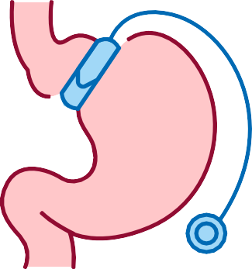
Gastric Band
This surgery is not often performed these days compared to the other surgeries as it generally not as successful. However, it may be considered on an individual basis. Weight loss is generally a lot slower and more steady compared to other types of bariatric surgery.
How it works: A band is placed around the upper part of the stomach, creating a small pouch. This means that less food is required to fill the pouch so you will feel fuller with a smaller amount of food.
Excess body weight lost: Typically around 50%.
Pros: It’s a relatively low risk, minimally invasive procedure. It usually results in a shorter hospital stay and a faster recovery time.
Cons: There is a risk that the band could slip out of position which can lead to heartburn, feeling sick and vomiting. This risk increases over time.

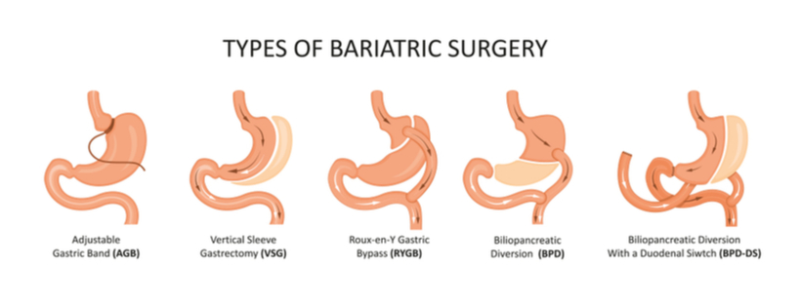
Sleeve Gastrectomy (Gastric Sleeve)
This surgery is an irreversible/permanent procedure. It is not typically recommended for those with reflux issues as this can be a common side effect following the surgery.
How it works: The stomach is made smaller by removing a large section of the stomach, leaving a long-sleeve shaped structure. This means that fullness is reached sooner with a smaller amount of food and appetite is reduced.
Excess body weight lost: Typically around 65%.
Pros: Lower risk of mortality compared to bypass.
Cons: Side effects such as acid reflux and sleeve twists/kinks (although twists are rare).

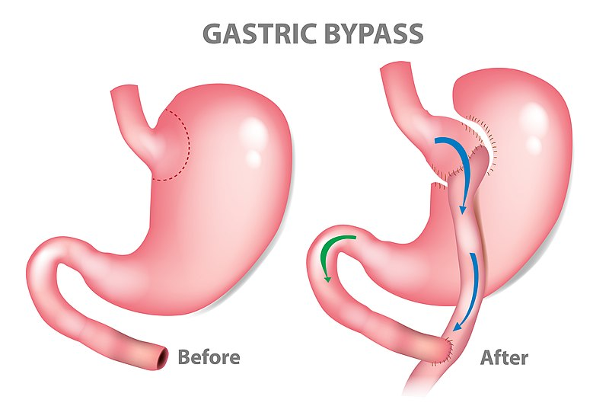
Gastric Balloon
A soft balloon, filled with a sterile solution is placed into the stomach (using a tube that’s passed down the throat), meaning you will feel fuller with a smaller amount of food. The balloon usually remains in place for up to one year. This is only temporary and is only offered prior to a more permanent bariatric surgery through the NHS.

Single Anastomosis Gastric Bypass
This surgery is similar to the Gastric Bypass, however the stomach and small intestine are connected in one join, rather than two separate joins. Further medical assessment can help to identify which specific type of surgery may be more beneficial on an individual basis.
Roux-en-Y Gastric Bypass
This surgery is an irreversible/ permanent procedure. It is a more complex procedure than the Sleeve. It may be recommended over the Gastric Sleeve for those with reflux issues or those who have a larger amount of weight to lose.
How it works: A small pouch is created at the top of the stomach, which is then connected to the small intestine, meaning any food passing through will not go through (bypass) the rest of the stomach. This means that fullness is reached sooner with a smaller amount of food and less calories (and nutrients) will be absorbed from foods.
Excess body weight lost: Typically around 65-75%.
Pros: Potentially a better option for those with reflux, a higher percentage of weight may be lost compared to other surgeries.
Cons: Higher risk of Dumping syndrome and low blood sugars.

Is surgery the right option for me?
It is worth having a really good think about how surgery would fit into your lifestyle and if it’s something that you think can realistically be managed for the rest of your life. It may help to make a ‘pros and cons’ list of having the surgery (making it personal to you) to help decide if the pros outweigh the cons or visa versa and if it is the right decision at this time or not.
Considering the questions below may also help:
• What am I hoping to achieve? Would bariatric surgery help me to achieve this?
• Do I feel like I have tried all other options to achieve my aims?
• What are the pros and cons of surgery for me?
• What are the types of surgery that would fit best into my life?
• How will the surgery affect my lifestyle? What will be different?
• What challenges may I have after the surgery (including physical, psychological, social)?
• What support do I require before and after the surgery and will I be able to obtain this?
• Is now the right time? Consider how stable your life is at the moment e.g. job security, finances, relationships, mental health, commitments, how much focus can be given to the surgery and the changes that come with it to have the greatest chance of making it a success.
What can help to increase successful outcomes after the surgery?
To help with success after surgery:
• Eat three balanced meals per day with no snacks in between.
• Take small bites and chew food well.
• Take time with meals, putting cutlery down between bites,
meals should take 15-20 minutes.
• Plan meals, ensuring consistency.
• Prioritise protein and fruit/veg at mealtimes.
• Be mindful of nutritional intake.
• Avoid unhelpful eating patterns such as grazing and binge eating.
• Sit down to eat in suitable eating environment.
• Avoid drinking and eating at the same time (stop drinking 30 minutes
before a meal, start drinking 30 minutes after a meal).
• Drink at least 2000ml of still, sugar free fluid per day.
• Avoid fizzy drinks completely.
• Avoid/limit (when safe to have) alcohol.
• Do not smoke.
• Take multivitamins/supplements recommended.
• Exercise regularly.
• Attend regular appointments.
Where can I find further information about bariatric surgery?
Obesity UK
https://www.obesityuk.org.uk/support-groups
You can also find support groups on Facebook by searching for ‘Obesity UK’ or ‘HOOP’ (Helping Overcome Obesity Problems).
Weight Loss Support Group Information
If you do attend these Zoom sessions please ask a member of staff to provide you with certification evidence of attendance for two of the Sunday sessions as this is a requirement to be put forwards for surgery in Leeds.
Obesity UK Bariatric Surgery Support Group
This group runs two weekly Zoom meetings for people who have had weight loss surgery (or are thinking about having it). You can access these via their Facebook page or by clicking the Zoom link:
• Facebook: Obesity UK Bariatric And Metabolic Surgery Support Group https://www.facebook.com/groups/21085065840
• Time: Sunday and Wednesday evenings, 7:30pm
• Join Zoom Meeting: https://zoom.us/j/6258094672
• Meeting ID: 625 809 4672
If you are struggling with accessing this online, please contact one of the following people for support:
• Leeds Libraries: 0113 378 5005 (Monday - Saturday, 10:00am - 4:00pm). They offer digital support over the telephone and in person (in libraries across the city).
• Leeds Libraries Online Guide: https://my.nicheacademy.com/leedslibraries/course/29108 has some videos that show people how to use the NHS app and the NHS website.
Speaker videos are now available to view:
• These videos have been recorded from our Wednesday night meetings.
• To view the videos, simply click on the link below, fill in your details and you will receive an email with a password.
• https://www.redhotirons.com/form/obesity-uk-support-group-video-access#form

Suggested reading and podcasts
• NHS website on bariatric surgery: https://www.nhs.uk/conditions/weight-loss-surgery/
• Book: ‘Living with Bariatric Surgery: Managing your mind and your weight’ by Denise Ratcliffe.
• Living with Bariatric Surgery podcast interview with Denise Ratcliffe: https://www.weightlosssurgerypodcast.com/102-living-with-bariatric-surgery-a-conversation-with-author-denise-ratcliffe-dclinpscyh/
• Interview with Prof. Batterham: https://www.rnz.co.nz/national/programmes/saturday/audio/201837136/rachel-batterham-gut-reactions-to-obesity

www.leedscommunityhealthcare.nhs.uk
© Leeds Community Healthcare NHS Trust, February 2024 ref: 2878

